Turbo Down Under: Great Britain Veterans Rifle Team in Australia, October 2026
Andy "Turbo" Barnes ('76–'83) is Secretary of the Bedfordians Rifle Club. After captaining the England Rifle Team to Kenya and South Africa in 2023, he was selected for the first Great Britain Veterans tour to Australia this October. This is his account of a successful tour that became something of a family affair.

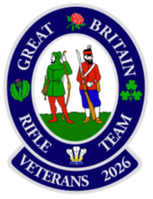
Target rifle shooting is one of very few sports where women and men of every age compete side by side, on equal terms and with no handicaps. For nearly 50 years the Bedfordians Rifle Club has helped pupils, Old Bedfordians and their families keep shooting beyond school, or return to it later in life. Since the MOD withdrew support for cadet fullbore shooting, that role matters more than ever. The club builds on the state-of-the-art .22 range run at the school by Peter Lumley-Wood. Thanks to the Bedford School Foundation Trust, it now has fullbore rifles and equipment to help leavers and OBs make the step up. We hope this story inspires the school and its pupils to take shooting even further. To find out more or get involved, visit bedfordiansrc.org or email contact@bedfordiansrc.org.
A honeymoon with chaperones
Most newlyweds honeymoon somewhere quiet. My daughter Nia and her husband Tom Drysdale, married the weekend before we flew, spent theirs at Belmont Ranges in Brisbane with the Great Britain Australia team, the GB Under 25s, the GB Veterans (all aged 60+) and, worst of all, her father. Tom was shooting for the main GB team, Nia for the Welsh squad, and I was there with the Veterans. I promised to give them space. I kept that promise, apart from breakfast, the range, the bus and most evenings.
A first for the Veterans
This was the first-ever GB Veterans tour to Australia, and the first time the Southern Cross and John Fitzgerald Veterans matches had been shot. Both grew from the 2024 World Championships in South Africa, where the Chairs of the National Rifle Associations of GB and Australia agreed that veterans should compete internationally more often. The Southern Cross match, named after the constellation that lights the southern sky, now sits within the ICFRA (world governing body for fullbore rifle associations) Australia Match programme alongside the Open and Under 25 matches. The Australia Match is one of the three great overseas fixtures in target rifle shooting, with the Palma World Championship and America matches. Having started out on the reserve list, I was very proud to finally be on the plane to Brisbane, as very nearly the youngest member of the team aged 61!
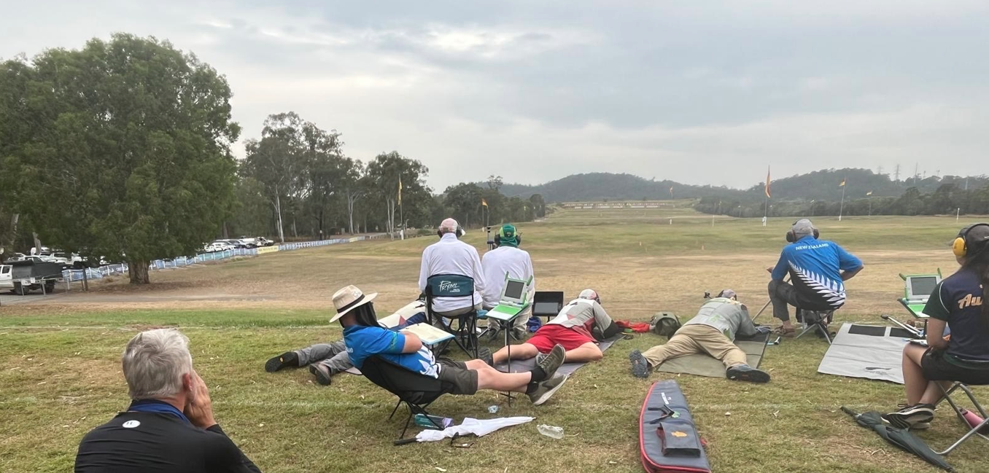 View from the 1000-yard firing point at Belmont Range, Brisbane, Australia. Andy ‘Turbo’ Barnes (in red) shooting in the John Fitzgerald Veterans Match
Learning to shoot all over again
First, an explanation of the scoring system for anyone not familiar with target shooting. The ‘bull’ is worth 5 points, the next ring (called an ‘inner’) 4 points etc. All the shoots in Australia were 10 shots. Therefore, the total “possible” score for 10 shots is 50 out of 50. To help differentiate ties, the bull has a centre circle half its diameter called the V-bull, still worth 5 points. If you are lucky enough to get all 10 shots in the V-bull, you’d get a score of 50.10. If you got 8 in the V-bull and 2 in the bull, then it would be 50.8, and so on.
The standard of shooting was world class: there were a lot of “possibles” and the difference between being 1st or 150th often came down to one or two points and V-bulls. I'd love to say I hit the ground running. I didn't. At Bisley we shoot in threes, taking turns on a target. It’s slow and exacting. In Australia it is all string shooting on the world-class Hexta electronic targets: you fire your whole score in one go, and the result flashes up on a screen seconds after the bullet lands. For the first couple of days, I felt like a man who learned to drive in a Morris Minor being handed the keys to a Formula One car. I scraped into the half team for the John Fitzgerald match.
Then something clicked. Once I'd worked out a strategy for string shooting, the scores climbed. On day two of the President's, I was top GB Veteran with 49.7 at 900 and 50.6 at 1000, 13th on the day and 6th in the 1000-yard competition. In the 900-yard shoot of the King's Prize, I was on course for a 50.10, but my last shot just missed the V-bull for a 50.9. I took bronze. Chris Mitchell of the GB team also scored 50.9 but took gold, having converted a bull sighter at the start. One sighter, one colour of medal.
I finished 5th GB Veteran in the Grand Aggregate (81st overall) and 4th Veteran in the President's (49th place). Best of all, I shot my way into the Southern Cross team. Not bad for a reserve with a slow start.
Two wins and one point
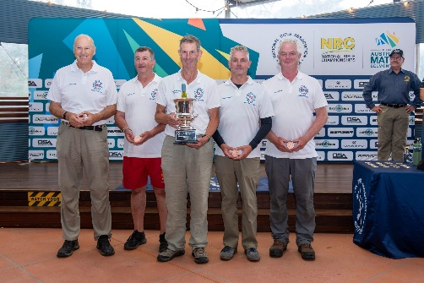
The GB Veterans won both John Fitzgerald matches. In the half team, GB scored 390.30 to Australia's 389.27 and New Zealand's 387.35, with my 50.7 at 1000 yards helping us over the line. The full team match went our way too, 783.72 to 778.68. Two matches completed, one to go.
GB Veterans winning half team, John Fitzgerald Match 2026, Belmont Ranges, Brisbane
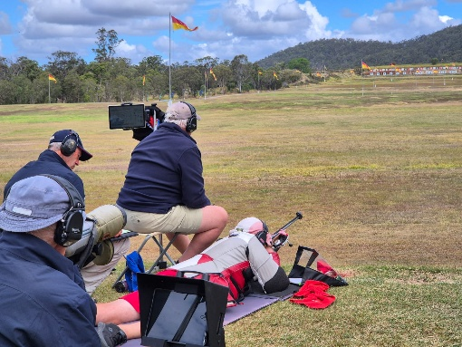
The Southern Cross, shot at 300, 600, 900 and 1000 yards, was a day of rain, wind and delays. When the range officer called a halt at 300 in a downpour, every Veteran checked whether his rifle was clear, then checked again, then asked the man next to him. We are Veterans after all, and sometimes we forget things! We led by five points going back to 1000 yards. Then came a cross fire: a perfectly good shot on someone else's target, and only a 4 at that. Australia won 1536.144 to our 1535.131. One point.
Nobody pointed fingers. Every shooter on both teams dropped points somewhere, and any one of us could have saved a couple. That's team shooting: you win together and lose together and support each other. Across the three matches we outscored Australia, which we have decided to call a moral victory.
A sport for everyone
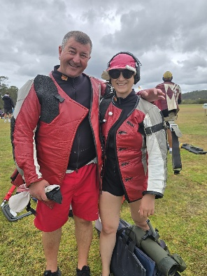
Shooting is one of the few sports where women and men compete on equal terms, and women very often come out on top. Both my daughters shoot for Wales. Fellow Welsh shooter Chloe Evans, of the GB Australia team, won the NRAA Grand Aggregate outright against a field of more than 200. The GB Australia team was captained by Jane Messer, who has shot, coached and captained in all of the big five: the National, Mackinnon, Kolapore, Australia and Palma matches. And Wales, with Nia in the squad, won the Australia half team match.
Andy ‘Turbo’ Barnes and daughter Nia on the ranges at Belmont, Brisbane
It is a family sport, too. My Australian equivalent turned out to be Australian Veteran Scott Brindley, shooting alongside his daughter Emma. We compared notes on the particular joy of being outshot by our children … and funding it!
Paul Sykes’s ‘OnTarget.live’ System: an online app showing every shot, live, anywhere in the world!
Let's be honest: fullbore is not a spectator sport. The targets are up to 1000 yards away and you can't see a thing without a spotting scope. Fellow Bedfordian Paul Sykes has changed that. His OnTarget.live online system links to the Hexta targets at Belmont and shows every shot as it lands, to anyone with a phone, anywhere in the world.
It made for real drama. Our Southern Cross was decided by the last shooters at 1000 yards. Even more gripping was the GB Under 25 Australia match, which came down to the very last of 200 shots. A bull would have won it. It was an inner, about half an inch out, and GB lost by a single V-bull. The whole range was glued to their phones, watching it unfold shot by shot. That moment was made possible by Paul's system and his hard work.
OnTarget.live: results of the John Fitzgerald half team match. Each name can be drilled down to view scores and targets at each range
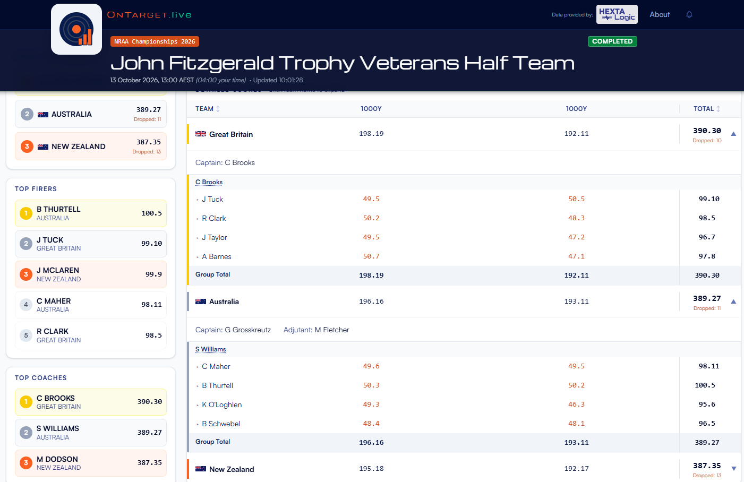
OnTarget.live: view of my shoots during the Southern Cross Match
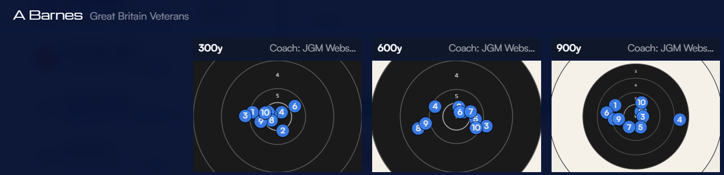
More than a score
Tours like this are about more than shooting. Between matches there was fishing, sightseeing and snorkelling, and a team barbecue that went some way to soothing the one-point Southern Cross defeat. My favourite moment came after the Southern Cross, over a drink with the Australians. The famous Pommy-Aussie needle was nowhere to be seen (well, they had won!), only warmth and humour. The real winner that day was fullbore shooting itself: friendly rivalry between nations and friendships across the globe. Losing by one point is a good reason to come back, and a great excuse to raise a glass with the people who beat you.
I started shooting at Bedford School in 1979, and I am still learning, still competing and still travelling the world in a GB blazer. So, to every Bedford School pupil shooting .22 on the school range: the step up to fullbore is smaller than you think, and the club is here to help you take it. To the girls joining the school next year: come and try. You will compete with the boys on equal terms from day one, and quite probably beat them. One day you might find yourself on a range in Brisbane, representing England, Wales, Scotland, Ireland or Great Britain.
Finally, thank you to the Bedford School Foundation Trust, the school and in particular Peter and Amy Lumley-Wood, for the commitment they put into continuing the strong and successful shooting tradition at Bedford School. It is even more important since the MOD withdrew support for cadet fullbore shooting. Your support is going exactly where it should: into giving young people the chance to do what I have been lucky enough to do for 47 years.
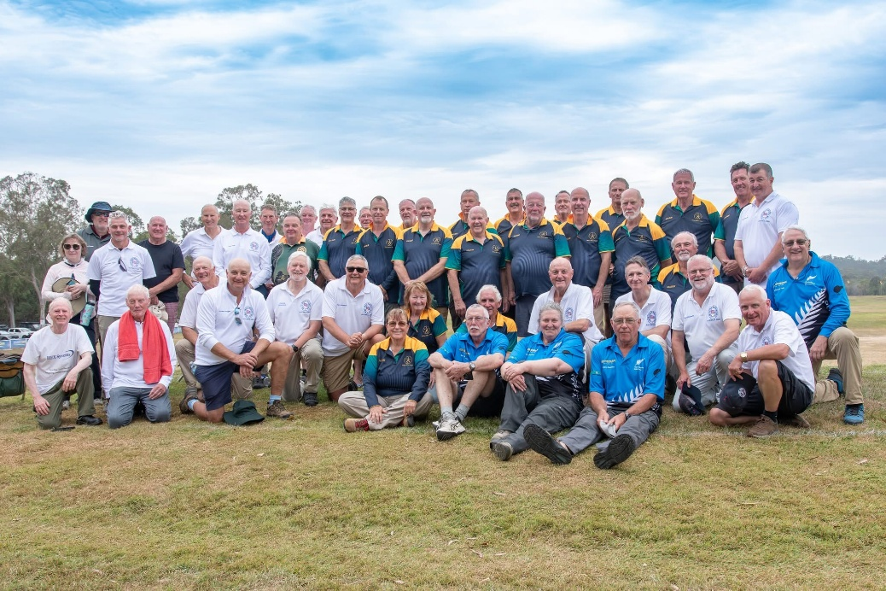
The Southern Cross Match 2026, Belmont Ranges, Brisbane, Australia
The Great Britain, Australia and New Zealand Veterans Rifle Teams

